
Consultation on Solid Fuel Burning

Questions (strictly related to health implications)

- Do you have any comments on the impact (positive or negative) resulting from the proposed new standard? This could be in terms of air quality, human health, the economy or the stove industry, for example.

The Royal College of General Practitioners (RCGP) is the professional membership body for GPs in the UK. Our purpose is to encourage, foster and maintain the highest possible standards in general medical practice. We support GPs through all stages of their career, from medical students considering general practice, through to training, qualified years and retirement.

The RCGP is a member of the UK Health Alliance on Climate Change and would encourage DEFRA to carefully consider their submission to this consultation.

While the RCGP does not seek to comment directly on specific energy or environmental policy decisions, which sit beyond our remit, we are well placed to highlight the implications of fuel burning and poor air quality for patients, clinicians, and the wider health system. The RCGP is committed to planetary health, including the improvement of air quality as a core component of protecting population health.

There is strong and consistent evidence that fuel burning contributes significantly to air pollution, with impacts on both health outcomes and environmental sustainability. In particular, lighting fires in our homes is one of the biggest sources of harmful fine particle air pollution in the UK. Research shows that using an indoor wood-burning stove or fireplace at least once a week is linked to a higher risk of breast cancer. Fine particulate pollution (PM2.5) also harms the heart and brain, increasing risks of stroke, dementia, and cardiovascular disease. It can impair children’s development and affect unborn babies during pregnancy. Even short-term exposure can stiffen arteries, promote clotting, and disrupt heart rhythm, raising overall mortality rates.

According to the World Health Organization, approximately 95 million disability-adjusted life years (DALYs) were attributable to household air pollution exposure in 2021.

Additionally, cutting down trees for fuel degrades natural ecosystems, harming planetary and population health, and weakening climate resilience. This underscores the substantial burden that environmental harm and air pollution places on individuals and communities worldwide.

The economic implications are also considerable. In 2019, costs to the NHS, productivity losses, and reductions in quality of life associated with air pollution were estimated to exceed £27 billion, as reported by the Royal College of Physicians in 2025. These figures illustrate the scale of the challenge for both public health and the sustainability of the health system. The RCGP has highlighted the importance of air quality as a social determinant of health, calling for further action within the 10 Year Health Plan as part of the Government’s prevention goals.

In this context, while specific policy mechanisms may fall outside our direct remit, we support measures that contribute to reducing fuel burning and improving air quality. Such approaches have the potential not only to improve patient health outcomes, but also to reduce pressures on general practice and the wider health system.

- To what extent do you agree or disagree that health labelling should be mandatory on solid fuel appliances? [Strongly agree; agree; neither agree nor disagree; disagree; strongly disagree; don’t know]. Please provide any evidence you have to support your response. [Open text box]

Strongly agree

- Please provide any evidence to support your response

According to research, people are typically not aware of the health harms of burning wood and other solid fuels. This lack of awareness can be addressed through mandatory labelling on fuel appliances, which communicates risk and allows consumers to make informed decisions regarding their health and safety.

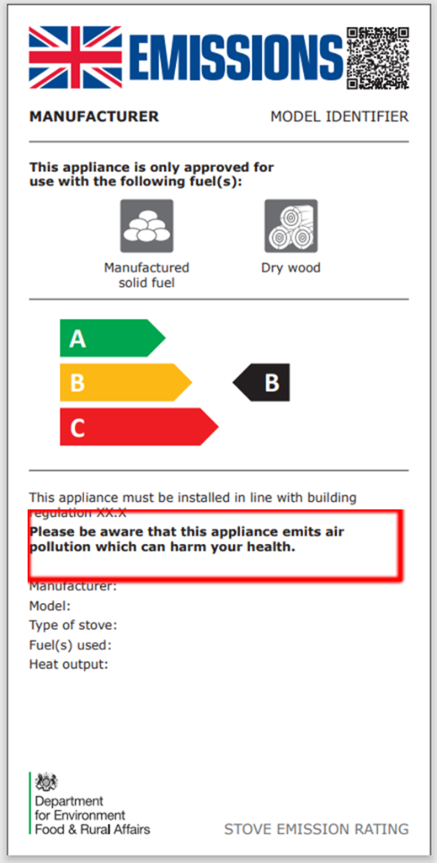

- To what extent do you agree or disagree that the example label above effectively conveys that there are health impacts of using solid fuels appliances to consumers? [Strongly agree; agree; neither agree nor disagree; disagree; strongly disagree; don’t know] Please provide further detail to support your response. [Open text box]

Neither agree nor disagree

- Please provide further detail to support your response.

While the RCGP has no particular view on which labelling methods are the most effective or appropriate, we would note that labels should be of adequate size, easy to understand and ensure visibility for the consumer. In addition, we would suggest that labelling should ensure that health risks are clearly highlighted.

GPs and primary care teams frequently see the impacts of air pollution on health, particularly among patients with respiratory and cardiovascular conditions such as asthma, COPD, and heart disease. Clear, accessible warnings can support prevention by raising awareness of environmental exposures that may exacerbate existing conditions or contribute to poorer health outcomes.

The RCGP strongly advocates for a whole-patient care approach that recognises the role of environmental factors, including air pollution, as important determinants of health. In this context, health messaging on appliances can play a valuable role in supporting public understanding of environmental health risks and encouraging behaviours that help reduce exposure. Evidence from the World Health Organization highlights that exposure to household air pollution contributes to respiratory and cardiovascular disease and remains a significant public health concern globally.

27.To what extent do you agree or disagree that the health statement “Please be aware that this appliance emits air pollution which can harm your health” is appropriate? [Strongly agree; agree; neither agree nor disagree; disagree; strongly disagree; don’t know]. If you disagree, please suggest an alternative health statement [Open text box]

Agree

- To what extent do you agree or disagree that health labelling should be mandatory on solid fuel packaging? [Strongly agree; agree; neither agree nor disagree; disagree; strongly disagree; don’t know]. Please provide any evidence you have to support your response. [Open text box]

Strongly agree
- Please provide any evidence you have to support your response
Mandatory health labelling on solid fuel packaging could support greater public awareness of the risks associated with burning solid fuels in the home.
Domestic burning is a significant source of fine particulate matter (PM2.5), one of the most harmful forms of air pollution, which is linked to serious health conditions including heart and lung disease, and asthma. In the UK, domestic wood and coal burning has been linked to approximately 2,500 deaths each year, highlighting the scale of the potential health impact.
Clear and consistent health warnings may therefore support prevention by improving public understanding of these risks and encouraging behaviours that reduce exposure.
45. Which of the following health statements do you prefer?

Option A: This product causes negative health impacts
Option B: This product causes negative health impacts to you and your family
Option C: Burning solid fuels to heat your home can lead to debilitating health conditions, including cardiovascular disease and asthma, which can result in premature death

Option C.

46. Please give a reason for your choice
Option C is preferable because it clearly describes the potential health consequences associated with burning solid fuels, including cardiovascular disease, asthma, and premature death.
In primary care, GPs frequently see patients with conditions that can be worsened by air pollution. A clear and specific statement about the health risks, as Option C provides, may be more effective in raising awareness and supporting informed decision-making than more general wording.
52. Do you have any additional evidence, data, or relevant information that should be considered by Defra to inform the development of these policies?

- White A.J. and Sandler D.P. (2017), Indoor Wood-Burning Stove and Fireplace Use and Breast Cancer in a Prospective Cohort Study (https://pmc.ncbi.nlm.nih.gov/articles/PMC5744698/)
- Henning R. (2024), Particulate Matter Air Pollution is a Significant Risk Factor for Cardiovascular Disease (https://www.sciencedirect.com/science/article/abs/pii/S014628062300511X)
- Oudin A. et al (2018), Association between air pollution from residential wood burning and dementia incidence in a longitudinal study in Northern Sweden (https://journals.plos.org/plosone/article?id=10.1371/journal.pone.0198283)
- Guercio V. et al (2021), Exposure to indoor and outdoor air pollution from solid fuel combustion and respiratory outcomes in children in developed countries: a systematic review and meta-analysis (https://www.sciencedirect.com/science/article/abs/pii/S0048969720357168)
- World Health Organization (2025), Household Air Pollution factsheet (https://www.who.int/news-room/fact-sheets/detail/household-air-pollution-and-health)
- Office for Health Improvement & Disparities (2022), Guidance: applying All Our Health (https://www.gov.uk/government/publications/air-pollution-applying-all-our-health/air-pollution-applying-all-our-health)
- Royal College of Physicians (2025), A breath of fresh air: responding to the health challenges of modern air pollution (https://www.rcp.ac.uk/policy-and-campaigns/policy-documents/a-breath-of-fresh-air-responding-to-the-health-challenges-of-modern-air-pollution/)
- Royal College of General Practitioners (2025), GPs sound the alarm on air pollution levels as asthma attacks rise dramatically to higher than five-year average (https://www.rcgp.org.uk/news/asthma-attacks-rise-dramatically)
- Global Action Plan (2025), Clean Air Public Insight Tracker, CAPIT 2025 Wave 4 (https://www.globalactionplan.org.uk/our-work/clean-air/clean-air-public-insight-tracker-capit)
- Global Action Plan (2026), Clean Air Night (https://www.cleanairhub.org.uk/clean-air-night#ref)
- Ricardo (2025), Research shows major health and economic benefits from reducing domestic burning in UK homes (https://www.ricardo.com/en/news-and-insights/press-releases/2025/research-shows-major-health-and-economic-benefits-from-reducing-domestic-burning-in-uk-homes)

